** Capital Area Agriculture & Horticulture Program**

**Serving Albany, Columbia, Greene,**

**Schenectady and Washington Counties**

**2013 Dairy Tour Farms**

**Hill-Over-Holsteins** is a meticulously managed, registered 84-cow, tie-stall operation owned by Fred Barringer since 1980. Along with receiving a TMR daily, cows are turned out every night to 2 acres of fresh high-quality forage, rotating between 40 acres of paddocks. Two years ago Fred took the risk of having his own milk bottled and selling it retail on his farm. The on-farm store, Hill-Over Healthy and Fresh, LLC is run with the help of his wife Donna. They also retail their milk at farmers markets and by home delivery. All the crop work on 230 acres is hired out. Fred maintains control of his crops and feed by purchasing all the crop inputs and paying two local farmers to bring in their machinery from planting through harvest and storage. One farmer plants and harvests the corn silage and haylage, which are packed into Fred’s bunks. Another grows, stores, and roasts his soybeans. By hiring out field work Fred can focus on the cows. As he says: “Details, details make the difference. Everyone can feed and milk cows, but it’s all in the details.”

**Landview Farm** with partners Rody & Jane Walker, Randy Walker, and Mark Anderson is a very well-managed 1225-cow dairy. Young stock is home-grown in their very efficient heifer barn. They also have a satellite farm in nearby Cambridge. Land and facilities are spread out over a wide area, which increases the challenges of manure, crops, and labor. Plus, they haul their own milk to Connecticut. Every farm operation is well-planned. Manure is direct loaded from tankers and incorporated behind the spreaders with an Aerway. Rye seed is applied with the manure in the fall. The corn planter follows a 6-row zone-builder for one-pass planting. Soil health is part of their philosophy. Forage quality is prime importance as they feed as high a forage diet as possible. They manage for high-quality milk and high milk components. Milk has been forward contracted and Landview has also participated in the Livestock Gross Margin – Dairy program - experience they can share. With a large and busy farm, Landview Farm also has good experience to share about labor management

**Dutch Hollow Farm** is owned and operated by Paul Chittenden and family. This herd of registered jerseys is one of the highest ranking in the nation. They have been known for years for their great genetics and cow families. In 2012 Dutch Hollow Farm received an award of great accomplishment, The Master Breeder Award. Since 1952, they have using polled genetics, starting with Paul’s father Stanley. Since then, they have contributed greatly to polled genetics within the jersey breed. Throughout the past few years Dutch Hollow has found different ways to market their milk, getting involved with Hudson Valley Fresh and Beecher’s Handmade Cheese. This year Dutch Hollow Farm will be one of the virtual dairy tours at World Dairy Expo. Along with great cows, Dutch Hollow has an extensive cropping program including corn, alfalfa, and soybeans. And with a large family taking part in the farm, managing labor is critical and contributes to their success.

**Capital Area Agriculture & Horticulture Program**

**Serving Albany, Columbia, Greene,**

**Schenectady and Washington Counties**

**2013 DAIRY TOURS – How Do You Manage Risk?**

**Hill-Over Holsteins – Fred & Donna Barringer**

**Wednesday, July 10, 1 to 3 pm**

**7441 State Rte 22, Copake**

(just north of the Rte 22 & Co Rte 3 intersection)

* 84-cow tie-stall grazing herd, managed meticulously
* Retail their own milk at on-farm store & home delivery
* Outsource all their crop work

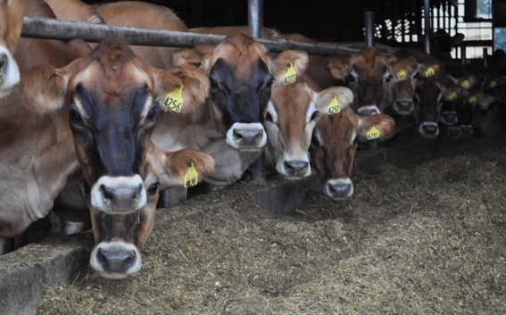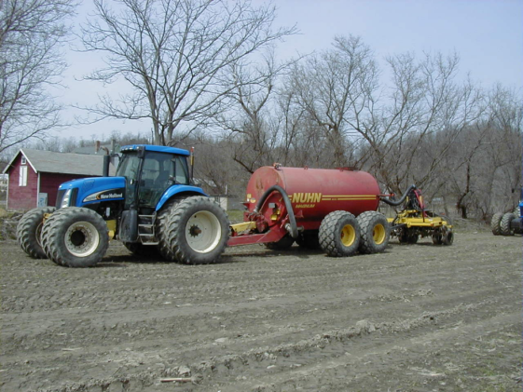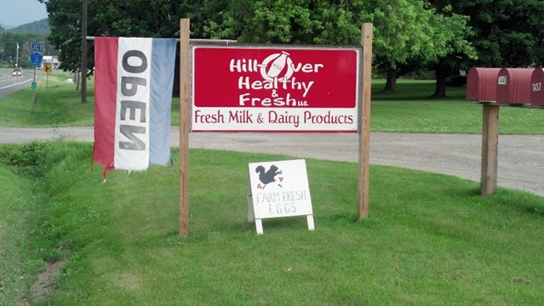

***GUIDED TOUR - PLEASE BE PROMPT***

FREE. Please RSVP so we have a tour packet & refreshments for you. Contact Katie Close (kec98@cornell.edu, 518-925-5806) or Aaron Gabriel (adg12@cornell.edu, 518-380-1496).

**Landview Farm – Rody & Jane Walker, Randy Walker, Mark Anderson**

**Wednesday, July 24, 1 to 3 pm**

**On County Rte 68, White Creek, Washington County**

(at the intersection of Co Rte 68 and Cobble Hill Rd.)

* Family & non-family partners and a satellite farm
* Soil health, winter forages, one-pass corn planting
* Very efficient heifer barn

**Dutch Hollow Jerseys— Chittenden family**

**Wednesday, August 14, 1 to 3 pm**

**101 Running Creek Rd., town of Kinderhook**

High-quality milk marketed in unique ways.

* Family partners in a Jersey herd focused on breeding
* Market high-quality milk to local name-brand processors
* Experience at fostering good neighbor relations